Ideation Phase
Brainstorm & Idea Prioritization Template

Date | 30 September 2026
Team ID | SN-TRANSFORM-01
Project Name | Import Data using Transform Maps (Spreadsheet)
Maximum Marks | 4 Marks

Brainstorm & Idea Prioritization Template:
Use this worksheet to generate practical ideas for a repeatable ServiceNow employee-import workflow, from spreadsheet preparation through validation and dashboard reporting.
Prioritize ideas that protect data integrity, make transform outcomes explainable and remain feasible with Import Sets, Transform Maps and Coalesce.
Reference: https://www.mural.co/templates/brainstorm-and-idea-prioritization
Step-1: Team Gathering, Collaboration and Select the Problem Statement – Employee Import
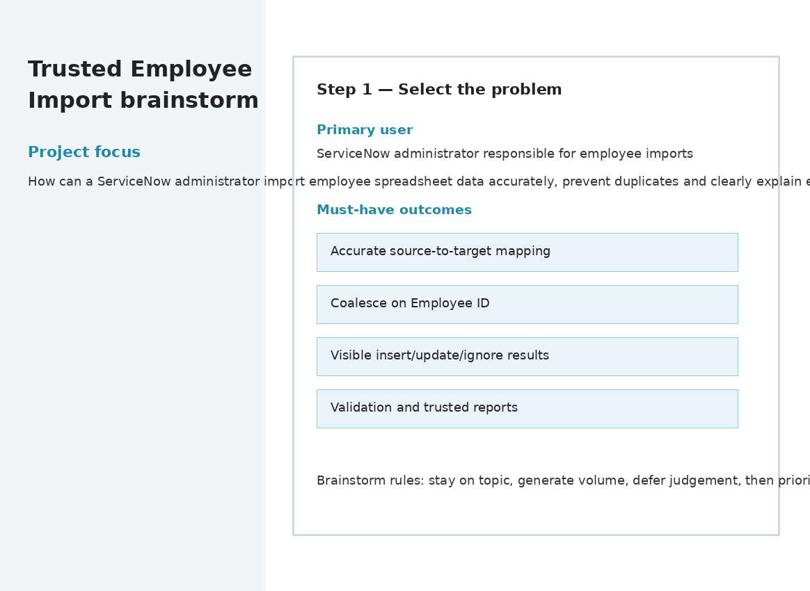

Step-2: Brainstorm, Idea Listing and Grouping – Employee Import
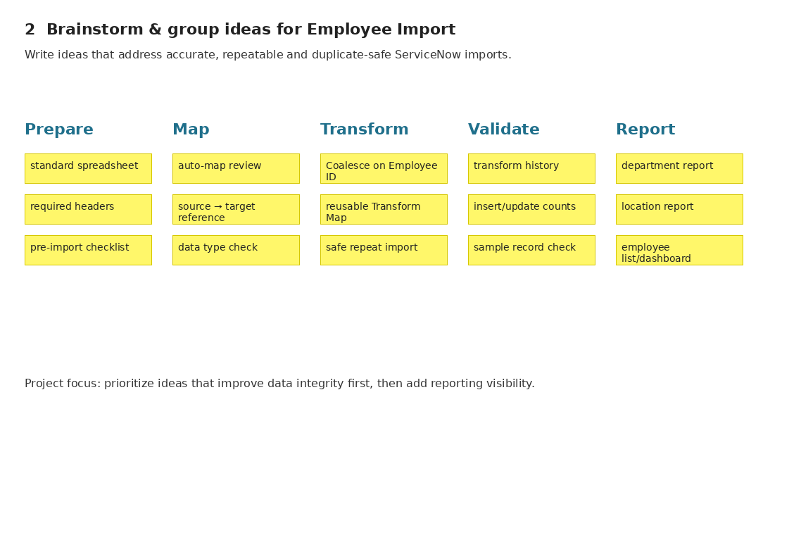

Step-3: Idea Prioritization – Employee Import
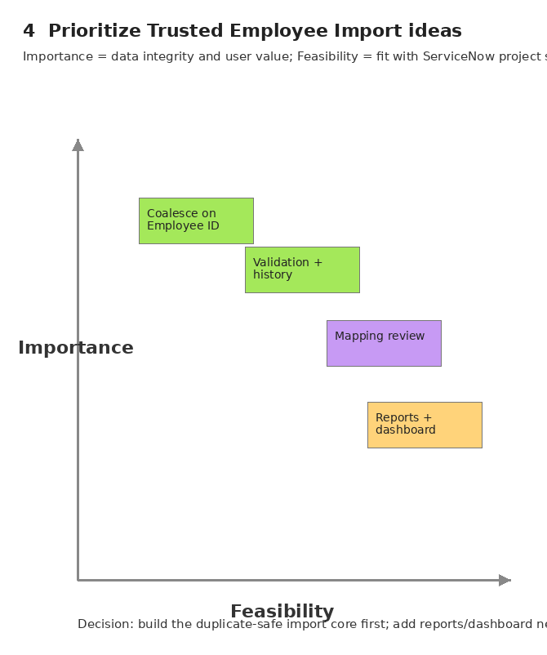

Project Completion Notes
Selected problem statement: A ServiceNow administrator needs to import employee spreadsheet data accurately and repeatedly, while preventing duplicates and clearly explaining inserts, updates, ignored rows and errors.
Idea listing and grouping
Group | Idea | Why it matters
Prepare | Standard spreadsheet template with required headers and a pre-import checklist. | Reduces header mismatch and avoidable load errors.
Map | Auto Map Matching Fields followed by explicit mapping review. | Combines speed with administrator control.
Transform | Set Coalesce = true on Employee ID. | Prevents duplicate employee records and enables updates.
Validate | Review transform history and compare source/target counts. | Makes inserted, updated, ignored and failed rows explainable.
Report | Create department, location and employee list reports. | Turns imported data into usable information.
Monitor | Add the three reports to an Employee Analytics Dashboard. | Provides ongoing visibility for HR and managers.
Idea prioritization
Priority | Selected idea | Score / 5 | Decision
1 | Coalesce on Employee ID + repeatable Transform Map | 4.9 | Must-have core
2 | Explicit mapping review after auto-map | 4.75 | Must-have control
3 | Validation and transform-history outcome summary | 4.65 | Must-have evidence
4 | Reports and Employee Analytics Dashboard | 4.0 | Value-adding extension
Selected direction: “Trusted Employee Import” — a guided use of the existing Import Set and Transform Map workflow that makes field mapping, Coalesce, transform outcomes and reporting easy to verify.

